**Lab 04 Submission Template**

**Name:** Carlos Henrique Maciel Sobral Timoteo

**Student Number:** 040905599

**Task 1 – 4 Marks** (0.5 marks lost for each missing or incorrect item)

Fill in the values in the fields below

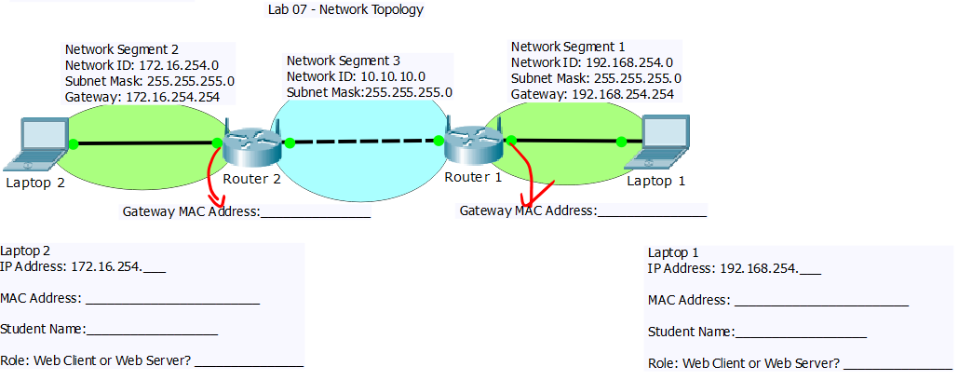

Router 1 :

Gateway MAC Address: B4-75-0E-AF-FC-98

Laptop 1:

IP Address: 192.168.254.35  
 MAC Address: 00-0C-29-60-08-8D  
 Student Name:Carlos Timoteo  
 Role: Web Server

Router 2 :

Gateway MAC Address: B4-75-0E-AF-FD-B5

Laptop 2:

IP Address: 172.16.254.46  
 MAC Address: 54-ee-75-7f-8c-76  
 Student Name:Hui Miao  
 Role: Web Client

**Task 1** (2 marks)

Step 8: Insert the screen capture of your routers routing table. **sc1-routingtable.** 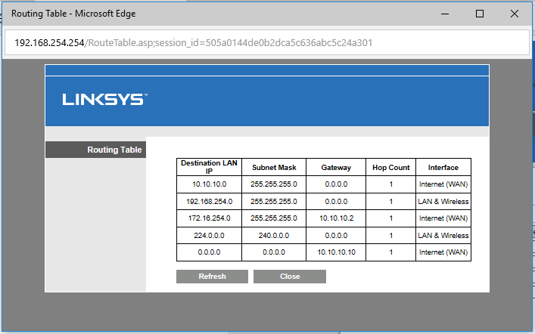

# Task 4: Observe NATed Network Traffic (4 marks)

Step 4: Insert the following screen capture below. Ensure your captures comply with the stated requirement (0 if they do not!)

To get 4 marks marks:

* both laptops capture the same HTTP traffic!
* Screen capture of summary pane with filter
  + - 1. 2 marks sc1-NAT-laptop1 if you are laptop 1.
      2. 2 marks sc1-NAT-laptop2 if you are laptop 2.

